Name:

**LAB#1**

**Exercise 1**

Kali linux Installed on virtual machine

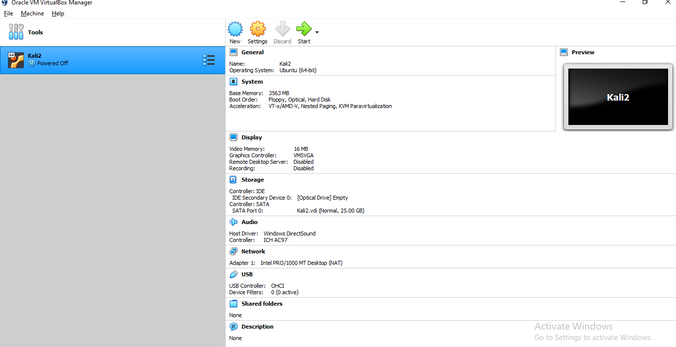

Exercise 2:

Kali linux booted successfully

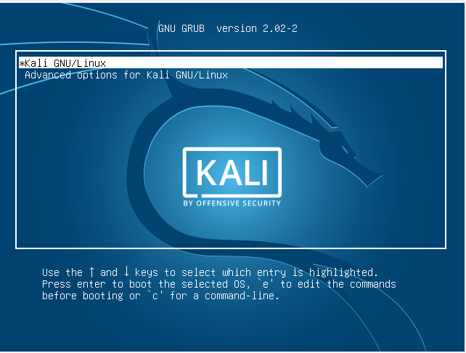

**Exercise 3:**

Packages updated and upgraded

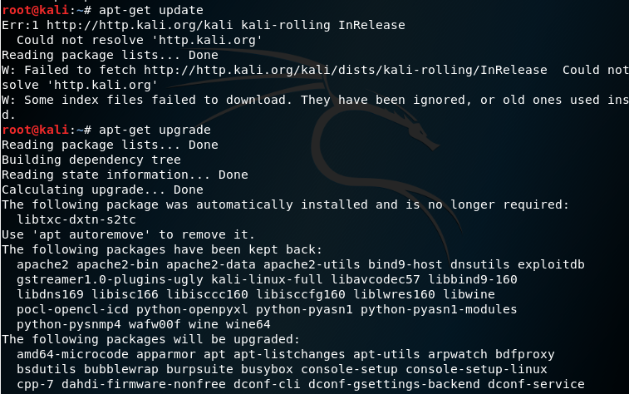

Interfaces updated

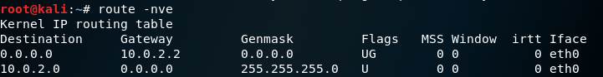

**Ping an Ip**

